Append PDPM/PMM Data

Overview

Current processing
PDPM – Preferred DPM (a.k.a. Preferred Market Maker, PMM), TPF is appending PDPM in Order Extension field currently.

New requirement
With TPF going away OHS has to append PDPM/PMM data. The appending of PDPM depends on two pre-requisites:
- There needs to be Routing Property (PDPM eligibility check) defined based on “Session/Order Origin Code” for an inbound Order with a flag of ‘Y’ (yes), if the flag is ‘N’ (no) then appending of PDPM will not take place.
- If the above is correct, the next Routing Property will be based on “Session/Exchange/Firm/Class/Correspondence/Branch” or “Session/ Exchange/Firm/Post/Station /Correspondence/Branch” that can contain up to 5 max PDPM acronyms.
The first Routing property can be defaulted (by using “DEFAULT” keyword) at Class or Post/Station level, and second one can be defaulted (by using “DEFAULT” keyword) at Correspondence and Branch level.
The inbound Order can have 1 max PDPM defined in optional field as “P:” if there is one defined then we add only 4 more PDPM and append it to the Extension field in the Order (total PDPM should not exceed 5).
In case of complex Order we have to get the Class from first Option leg.

Assumption
- If there is Firm in the key it will be always Exchange/Firm.
- If there is no Routing Property defined for PDPM eligibility then appending of PDPM will not take place even though there is PDPM defined in the incoming Order’s Optional field as “P:”
- If there is PDPM already present in the Extensions field of an incoming Order then log alarm and do not change any thing.
- We should always append PDPM provided in the Optional data field (with “P:”) of and incoming Order at the start of all other PDPM provided by Routing Property.
- If the PDPM provided in the Optional data field (with “P:”) of and incoming Order but the PDPM eligibility check Routing Property fails (defined as ‘N’) then don’t append it on Extensions field.
- Blank (empty string) is a valid value for Correspondence field in the key of Append PDPM data Routing Property.

PDPM Eligibility Check Routing Property key’s possible combination:
Routing Property Key |  | Value
Session | Origin Code | Value
W_MAIN | A | Y
W_MAIN | * | Y

PDPM Data Assignment Routing Property key’s possible combination (blank is also valid value for Correspondence):
Routing Property Key |  |  |  |  | Value
Session | Firm | Class | Correspondence | Branch | Value
W_MAIN | Firm1 | IBM | Corr1 | AAA | PMM1, PMM2
W_MAIN | Firm1 | IBM |  | AAA | PMM1, PMM2
W_MAIN | Firm1 | IBM | Corr1 | * | PMM1, PMM2
W_MAIN | Firm1 | IBM |  | * | PMM1, PMM2
W_MAIN | Firm1 | IBM | * | AAA | PMM1, PMM2
W_MAIN | Firm1 | IBM | * | * | PMM1, PMM2

Routing Property Key |  |  |  |  |  | Value
Session | Firm | Post | Station | Correspondence | Branch | Value
W_MAIN | Firm1 | Post1 | St1 | Corr1 | AAA | PMM1, PMM2
W_MAIN | Firm1 | Post1 | St1 |  | AAA | PMM1, PMM2
W_MAIN | Firm1 | Post1 | St1 | Corr1 | * | PMM1, PMM2
W_MAIN | Firm1 | Post1 | St1 |  | * | PMM1, PMM2
W_MAIN | Firm1 | Post1 | St1 | * | AAA | PMM1, PMM2
W_MAIN | Firm1 | Post1 | St1 | * | * | PMM1, PMM2
W_MAIN | Firm1 | Post1 | * | Corr1 | AAA | PMM1, PMM2
W_MAIN | Firm1 | Post1 | * |  | AAA | PMM1, PMM2
W_MAIN | Firm1 | Post1 | * | Corr1 | * | PMM1, PMM2
W_MAIN | Firm1 | Post1 | * |  | * | PMM1, PMM2
W_MAIN | Firm1 | Post1 | * | * | AAA | PMM1, PMM2
W_MAIN | Firm1 | Post1 | * | * | * | PMM1, PMM2
W_MAIN | Firm1 | * | * | Corr1 | AAA | PMM1, PMM2
W_MAIN | Firm1 | * | * |  | AAA | PMM1, PMM2
W_MAIN | Firm1 | * | * | Corr1 | * | PMM1, PMM2
W_MAIN | Firm1 | * | * |  | * | PMM1, PMM2
W_MAIN | Firm1 | * | * | * | AAA | PMM1, PMM2
W_MAIN | Firm1 | * | * | * | * | PMM1, PMM2

For detail please refer to Requirement document.

Implementation
Below are list of Classes needed for Routing Properties:

Check PDPM Eligibility Routing Property
RoutingPropertyKeyHelper (Existing)
RoutingPropertyTypeImpl (Existing)
SessionOriginKey (New)
SessionOriginKeyBeanInfo (New)
RoutingPropertyServiceImpl (Existing)
PDPMEligibleHandler (New)
BasePropertyKeyTypeImpl (Existing)
RoutingPropertyMaskHelper (Existing)
RoutingPopertyFactoryHelper (Existing)
RoutingPropertyARHelper (Existing)
PropertyServicePartialKeyClient (Existing)
EligiblePDPMGroupBeanInfo (New)
EligiblePDPMGroup (New)

Mask for this Routing Property:
int[][] PDPM_MASK =
{{0,1}};

Append PDPM Data Routing Property
RoutingPropertyKeyHelper (Existing)
RoutingPropertyTypeImpl (Existing)
SessionFirmClassCorrBranchKey (New)
SessionFirmPostStationCorrBranchKey (New)
RoutingPropertyServiceImpl (Existing)
PDPMAppendHandler (New)
PDPMAppendPostStationHandler (New)
BasePropertyKeyTypeImpl (Existing)
RoutingPropertyMaskHelper (Existing)
RoutingPopertyFactoryHelper (Existing)
RoutingPropertyARHelper (Existing)
PropertyServicePartialKeyClient (Existing)
PDPMAppendGroupBeanInfo (New)
PDPMAppendGroup (New)
PDPMAppendPostStationGroupBeanInfo (New)
PDPMAppendPostStationGroup (New)

Mask for this Routing Property:
int[][] APPEND_PDPM_MASK =
{{0,0,0,0,1},{0,0,0,1,0},{0,0,0,1,1}};
int[][]APPEND_PDPM_POST_STATION_MASK = {{0,0,0,0,0,1},{0,0,0,0,1,0},{0,0,0,0,1,1},{0,0,0,1,0,0},{0,0,0,1,0,1},{0,0,0,1,1,0},{0,0,0,1,1,1},{0,0,1,1,0,0},{0,0,1,1,0,1},{0,0,1,1,1,0},{0,0,1,1,1,1}};

Append PDPM Routing Property should only allow up to 5 max PDPM to be specified at the time of setting it. Therefore the GUI that provides the interface for setting or changing this Routing Property should restrict it to 5 maximum values using ACL read from CSV file.
The other Classes going to be used by this feature are ExtensionsHelper, OrderExtension, WFStepAppendPDPMData, WFStepAppendPDPMDataSimpleOrder, and WFStepAppendPDPMDataComplexOrder.

Append PDPM for Simple Order:
- WFStepAppendPDPMDataSimpleOrder will receive the request to append PDPM.
- In this Workflow step first we should check the Optional field using if(p_context.getOrder().getOptionalData().startsWith(“P:”))
        - If the above is true then there is one PDPM already provided, we have to parse that out and append four more.
        - If the above is false then there is no PDPM we can append five more (max 5).
- Build the key using RoutingPropertyKeyHelper and passing “Session/Order Origin Code” from the Order.
- Call RoutingPropertyServiceImpl.isPDPMEligible(BasePropertyKey key) to check if it’s allowed to append PDPM data.
- If it’s not allowed to append data then no appending will take place.
- If it’s allowed to append data then build the key using RoutingPropertyKeyHelper and passing “Session/Firm/Class/Correspondence/Branch” from the Order.
- Call RoutingPropertyServiceImpl.getPDPMData(BasePropertyKey key) to get PDPM data.
- If this property is not defined RoutingPropertyServiceImpl internally builds the key again by replacing Class with Post/Station e.g. “Session/Firm/ Post/Station /Correspondence/Branch”.
- And call RoutingPropertyServiceImpl.getPDPMDataPostStation(BasePropertyKey key) to get PDPM data.
- Merge the PDPM that we got from Optional Data field with the data we got back from above call using OrderExtension.getExtensions (String newExtensions, String oldExtensions), up to 5 maximum.
- Set this PDPM in Order using p_context.getOrder().setExtensions() with the help of ExtensionsHelper, so that we do not loose any other previously assigned Extensions field values.
- After the above logic completes pass the control to next Workflow step in line.

Append PDPM for Complex Order:
- WFStepAppendPDPMDataComplexOrder will receive the request to append PDPM.
- In this Workflow step first we should check the Optional field using if(p_context.getOrder().getOptionalData().startsWith(“P:”))
        - If the above is true then there is one PDPM already provided, we have to parse that out and append four more.
        - If the above is false then there is no PDPM we can append five more (max 5).
- Build the key using RoutingPropertyKeyHelper and passing “Session/Order Origin Code” from the Order. And use Class based on Product from Order’s first Option leg.
- Call RoutingPropertyServiceImpl.isPDPMEligible(BasePropertyKey key) to check if it’s allowed to append PDPM data.
- If it’s not allowed to append data then no appending will take place.
- If it’s allowed to append data then build the key using RoutingPropertyKeyHelper and passing “Session/Firm/Class/Correspondence/Branch” from the Order. And use Class based on Product from Order’s first Option leg .
- Call RoutingPropertyServiceImpl.getPDPMData(BasePropertyKey key) to get PDPM data.
- If this property is not defined RoutingPropertyServiceImpl internally builds the key again by replacing Class with Post/Station e.g. “Session/Firm/ Post/Station /Correspondence/Branch”.
- And call RoutingPropertyServiceImpl.getPDPMDataPostStation(BasePropertyKey key) to get PDPM data.
- Merge the PDPM that we got from Optional Data field with the data we got back from above call using OrderExtension.getExtensions(String newExtensions, String oldExtensions), up to 5 maximum.
- Set this PDPM in Order using p_context.getOrder().setExtensions() with the help of ExtensionsHelper, so that we do not loose any other previously assigned Extensions field values.
- After the above logic completes pass the control to next Workflow step in line.

Scripts
- None

Database
- None

SetContext

XML/DTD

Homes/Services
- RoutingPropertyServiceHome, RoutingPropertyServiceHomeImpl
- RoutingPropertyService, RoutingPropertyServiceImpl

ImplPlan
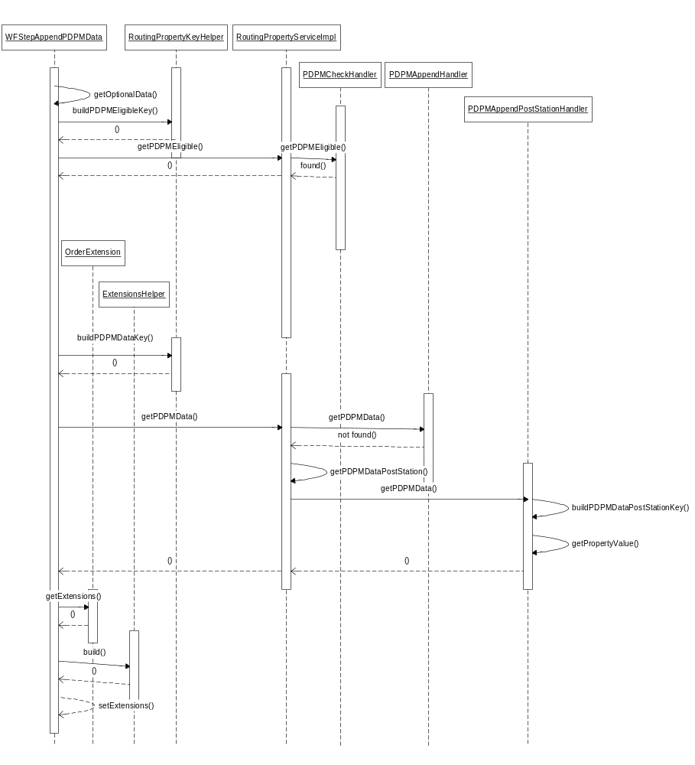

PerformanceTestingProcedure
- .

TestingProcedure
- Using the SA GUI set the Routing Property for PDPM eligible using Session/Order Origin Code to ‘Y’ (Yes).
- Using the SA GUI set the Routing Property for Append PDPM data using Session/Firm/Class/Corr/Branch and assign five different PMM to it.
- Enter Order from Trader GUI with one PDPM in the Optional field starting with “P:”
- After Order gets routed verify the Order’s column has total of five PDPM appended, first from the Optional field and four from Routing Property (fifth PDPM on Routing Property should not be there).

OperatorProcedure
- .

Fallback/Failover

